**REPORT**

**ROCK-PAPER-SCISSORS GAME**

**Problem Statement: Simple game Ai for Rock-Paper-Scissors**

****Name**- Anshika Gautam**

****University Roll no**. - 202401100300054**

****Branch-Sec** - CSE(AI)-A**

***Introduction***

The Rock, Paper, Scissors game is a simple hand game usually played between two players, where each player simultaneously forms one of three shapes with their hand: rock, paper, or scissors. The objective of this project is to develop an AI-based Rock, Paper, Scissors game in Python, where the user plays against a computer opponent that makes random choices.

***Methodology***

1. The game is implemented using Python and utilizes the random module to simulate AI moves.

2.The user is prompted to input their choice (rock, paper, or scissors), and the AI selects a move randomly.

3. A function determines the winner based on predefined rules:

Rock beats Scissors

Rock beats Scissors

Paper beats Rock

If both choices are the same, the game is a tie.

1. The game allows continuous play with an option to exit.

5.The code is developed in Google Colab with proper comments for better understanding.

***CODE :***

import random

def get_ai_move():

return random.choice(['rock', 'paper', 'scissors'])

def get_user_move():

move = input("Enter your move (rock, paper, scissors): ").lower()

while move not in ['rock', 'paper', 'scissors']:

print("Invalid move. Please choose either rock, paper, or scissors.")

move = input("Enter your move (rock, paper, scissors): ").lower()

return move

def determine_winner(user_move, ai_move):

if user_move == ai_move:

return "It's a tie!"

elif (user_move == 'rock' and ai_move == 'scissors') or \

(user_move == 'paper' and ai_move == 'rock') or \

(user_move == 'scissors' and ai_move == 'paper'):

return "You win!"

else:

return "You lose!"

def play_game():

print("Welcome to Rock, Paper, Scissors!")

while True:

user_move = get_user_move()

ai_move = get_ai_move()

print(f"AI chose {ai_move}.")

result = determine_winner(user_move, ai_move)

print(result)

play_again = input("Do you want to play again? (yes/no): ").lower()

if play_again != 'yes':

print("Thanks for playing!")

break

play_game()

**RESULT**

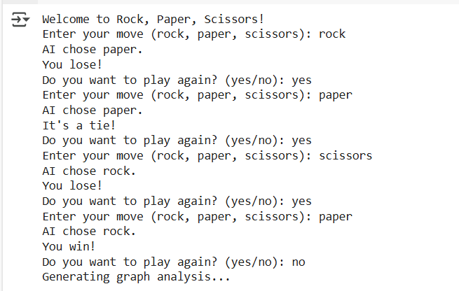

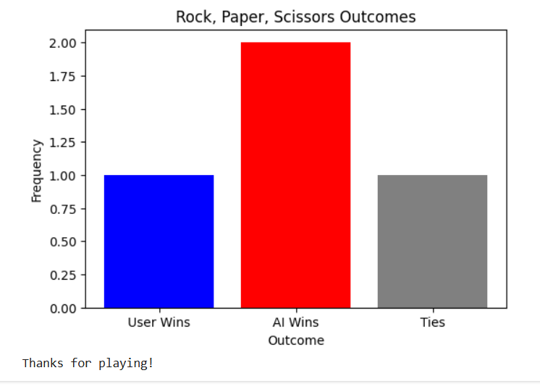

***References***

Python Official Documentation: <https://docs.python.org/3/>

Google Colab for code execution

Random module for AI move generation